Prototyping and Developing Machine Learning Models

Lab 01: Deploying an ML Model with Cloud Run
Introduction
In this hands-on lab, you will learn how to deploy a trained machine learning (ML) model to the cloud, enhancing its availability and performance. By containerizing the application, storing the container in a registry, and deploying it on Google Cloud Run, you will gain practical experience in modern deployment practices, ensuring your ML model is accessible and scalable.
Problem
Many data scientists and ML practitioners face challenges in deploying their trained models in a manner that ensures high availability, scalability, and ease of access. Traditional deployment methods can be cumbersome, requiring significant effort to manage infrastructure, ensure performance, and handle scaling. Additionally, ensuring the seamless integration of ML models into existing workflows and applications can be complex and time-consuming.
Solution
The solution involves containerizing the pre-trained ML model, storing it in a container registry, and deploying it on Google Cloud Run. This approach leverages the power of containerization to encapsulate the application along with its dependencies, ensuring consistency across different environments. Google Cloud Run, a fully managed compute platform, automatically handles scaling, load balancing, and infrastructure management, providing a robust and efficient solution for deploying ML models. By following this lab, you will learn how to take your ML model from code to a deployed service in the cloud, making it easily accessible and performant.

Step 01: Enabling API
- Sign in to Google Cloud Platform.
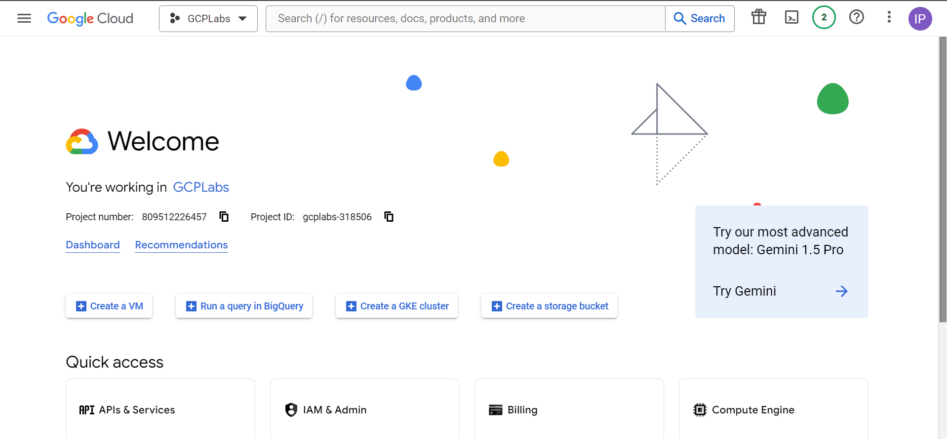
- In the Google Cloud console, click the three-line menu on the top left to open the main navigation menu.
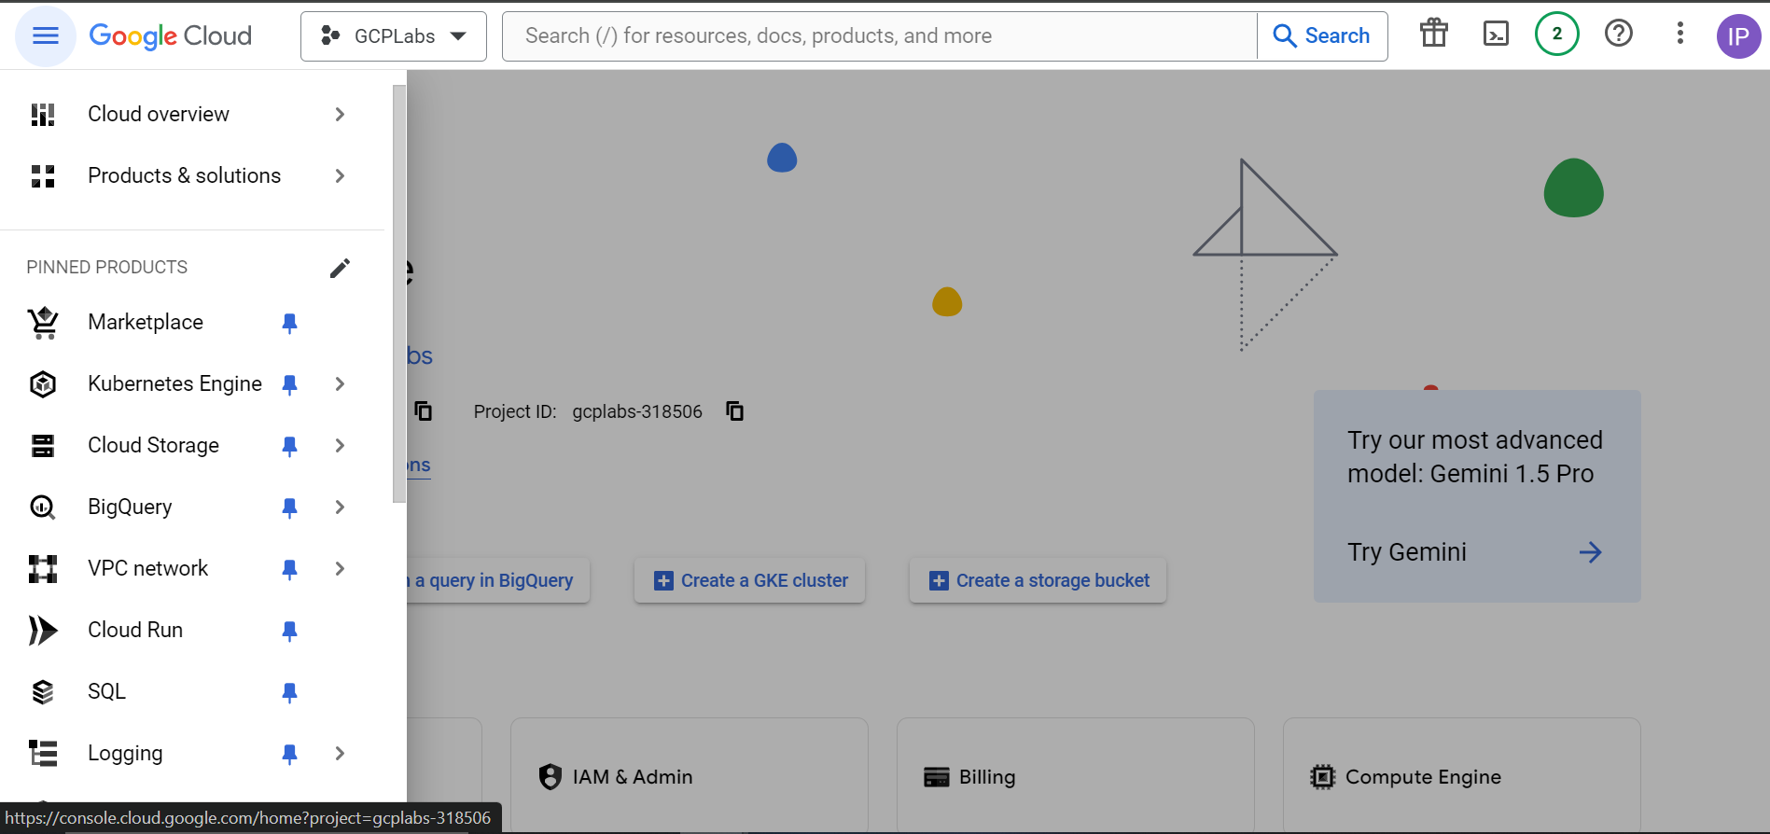
- Select APIs & Services > Library.
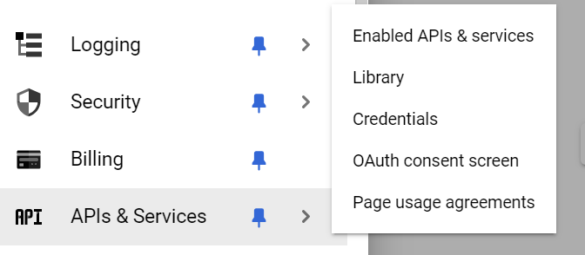
- In the search box, search for build, and select the Cloud Build API tile from the results.
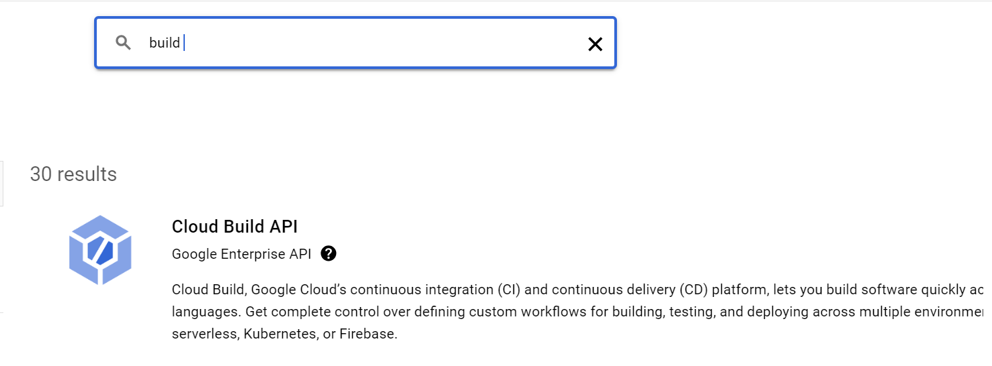
- Click Enable or if it is already Enabled it will show Manage.
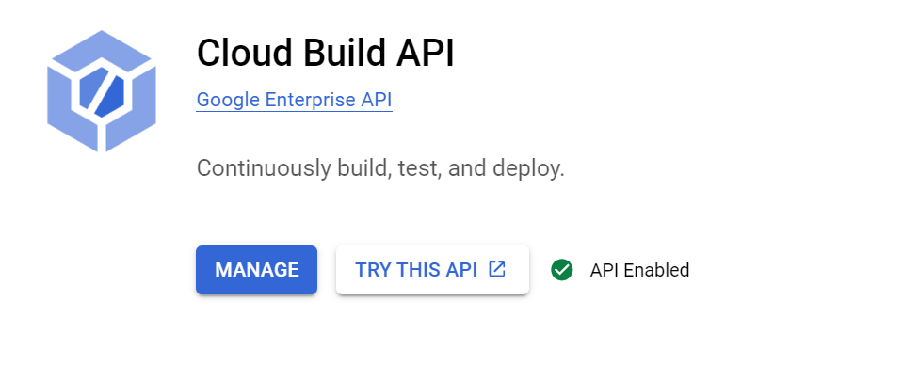
- Once the Cloud Build API is up and running, from the APIs & Services menu on the left, click Library.
- On the API Library page, use the top search bar to enter and search for run.
- Click the Cloud Run Admin API from the results.
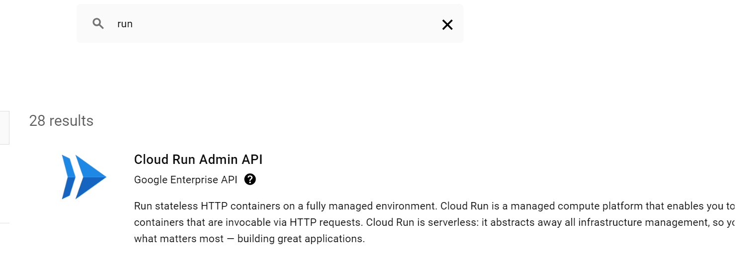
- On the Cloud Run API page, click ENABLE if already enable it will show Manage and API Enabled.
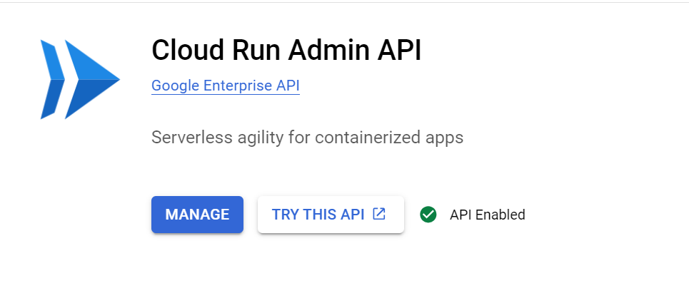

Step 02: Retrieve the Working Files
- Navigate back to the main dashboard by clicking the three-line menu to open the main navigation menu.
- Select Cloud overview > Dashboard.
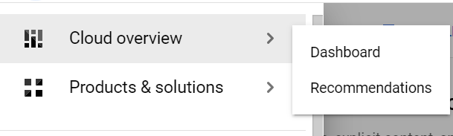
- Click the Cloud Shell icon (>_) on the top right of the page to activate Cloud Shell.
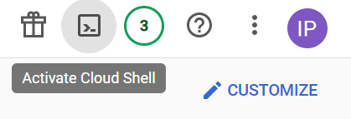
- Click Continue.
- Retrieve the GitHub files https://github.com/linuxacademy/content-google-cloud-certified-professional-machine-learning-engineer using git clone command.
- To verify the repo has been cloned, run the list command, ls.
- Move to this folder using the cd command.
- Run ls to see the contents of the repo.You should see the folder, deploying-ml-model.
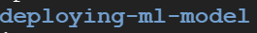
- Run the cd deploying-ml-model command to change into that directory.
- Run ls to see the contents of the directory.
- To examine the contents of the directory more closely, from the top menu bar of the Cloud Shell, click Open Editor > Open in a new window.
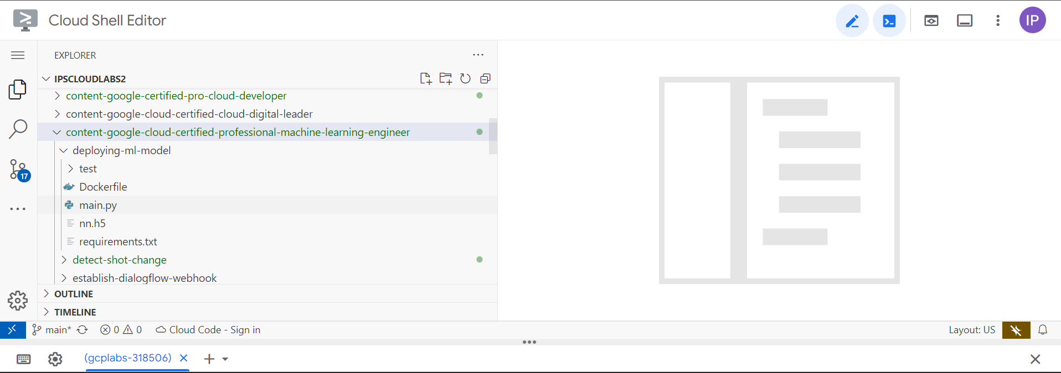
- In the new tab, click the arrow next to the content-google-cloud-certified-professional-machine-learning-engineer folder to display its contents, and then also click the arrow next to the deploying-ml-model folder.
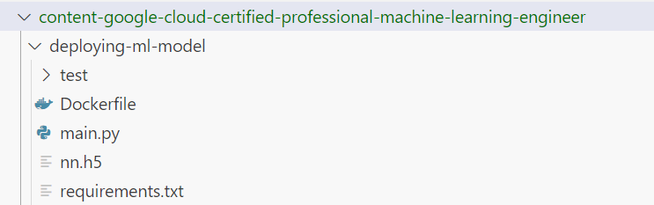
- You can optionally click on the main.py file to see the code. The nn.h5 file contains all of the training code, but it cannot be opened by this editor. You can also click on the Dockerfile. It is the most important file, as it includes all of the instructions that Cloud Build will use to containerize your app.

Step 03: Containerize the App and Store the Disk Image
- Click Open Terminal and open it in a new window.
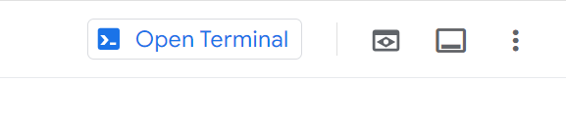
- Invoke the Cloud Build service to create the container and store it in Container Registry, by running the following command. Be sure to replace {PROJECT_ID} with your project ID, which is shown at the end of the first line of the terminal .
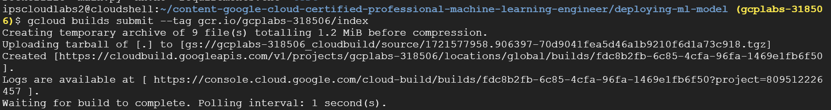
- In the Authorize Cloud Shell popup, click AUTHORIZE.
- Deploy the containerized image to Cloud Run, by running the following command. Be sure to again replace {PROJECT_ID} with your project ID.
- When prompted for the Service name (index), enter get-predictions and press Enter.
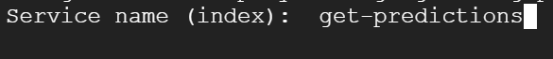
- When prompted to specify a region, enter 28 for us-east-1 and press Enter.
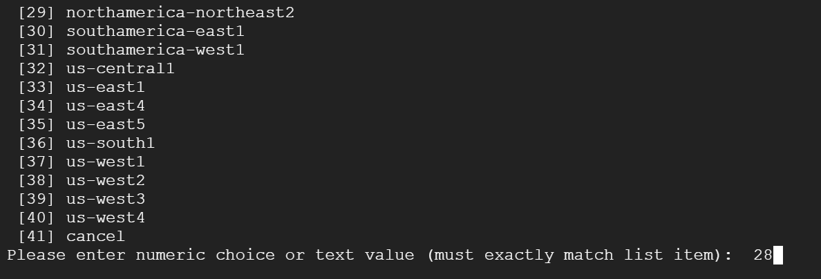
- When asked about allowing unauthenticated invocations, enter y for yes and press Enter.
- When the deployment is complete (You will see Done.), on the second-to-last line, copy the Service URL to your clipboard to use in your testing.

Step 04: Deploy the Disk Image to Cloud Run
- Return to the editor in your other tab and click on the test folder > test.py file.
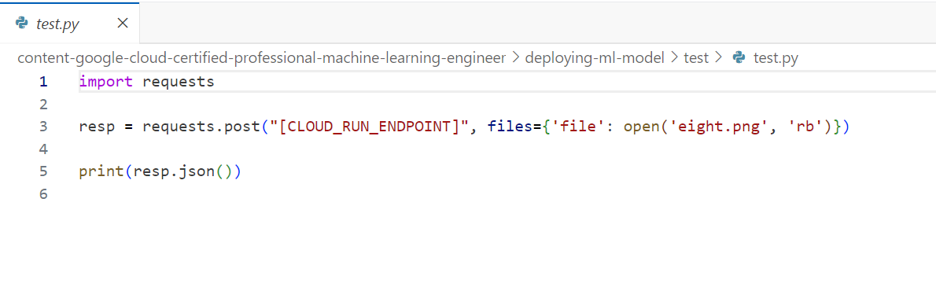
- Replace the [CLOUD_RUN_ENDPOINT] on line 3 with the Service URL endpoint you just copied. You can also see on the same line that the file it is working with to do this prediction is eight.png.
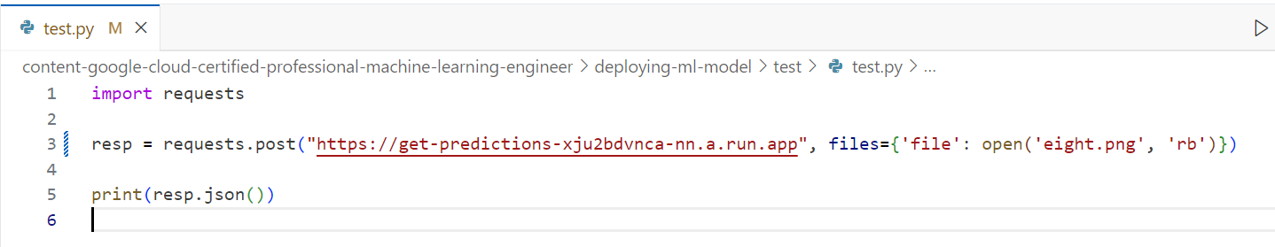
- You can also see on the same line that the file it is working with to do this prediction is eight.png. You can see that it shows a roughly drawn number 8. This trained model uses these images in order to recognize them.
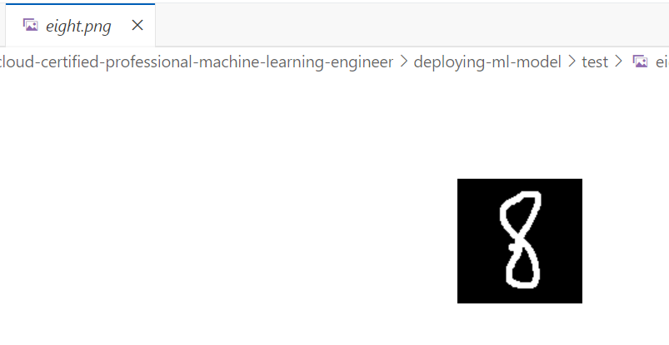
- Close the eight.png file tab.
- With the test.py file tab still open, click File > Save to save the changes.
- Return to your Cloud Shell terminal tab.
- Run cd test.
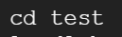
- Then, run python test.py.You should see prediction: 8 in the output, showing that the trained model is working.
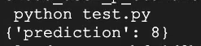
- Return to your editor tab.
- On line 3, replace eight.png with three.png.
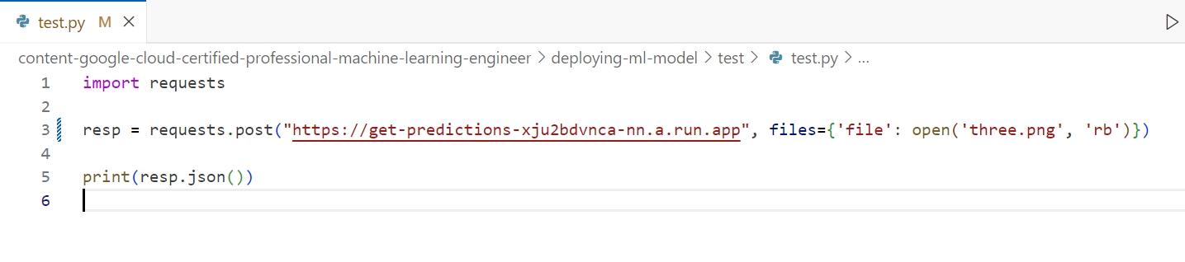
- Return to your Cloud Shell terminal tab.
- Run python test.py.You should see ‘prediction’: 3 in the output this time, showing again that the trained model is working.
